1.

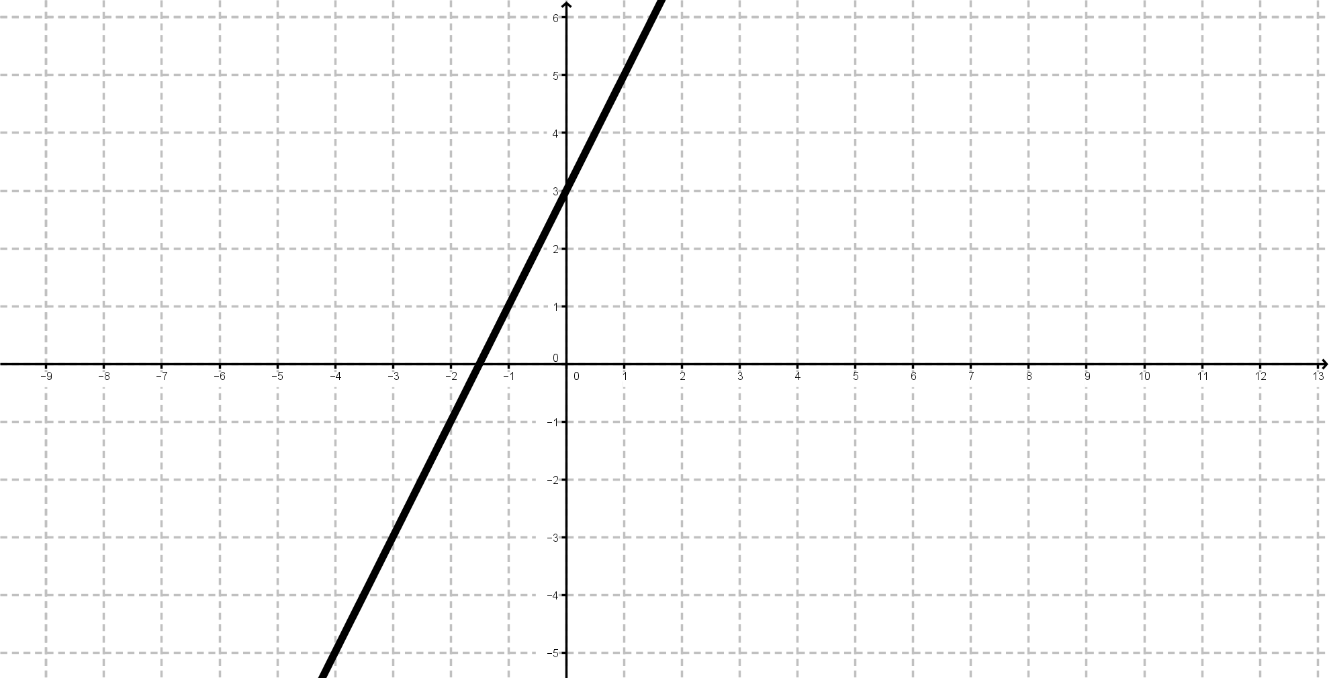

Go to the y-intercept of this graph.

2.

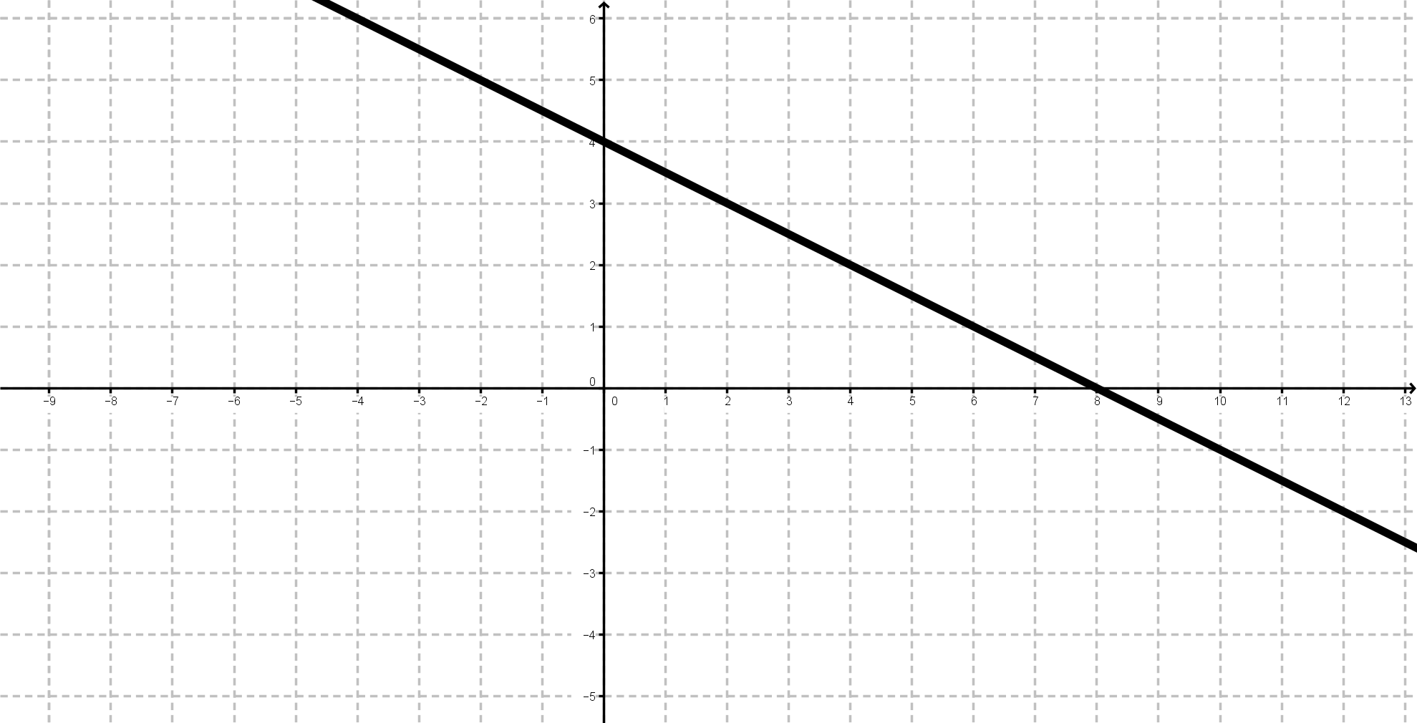

Go to the x value of this graph when y = -1.

3.

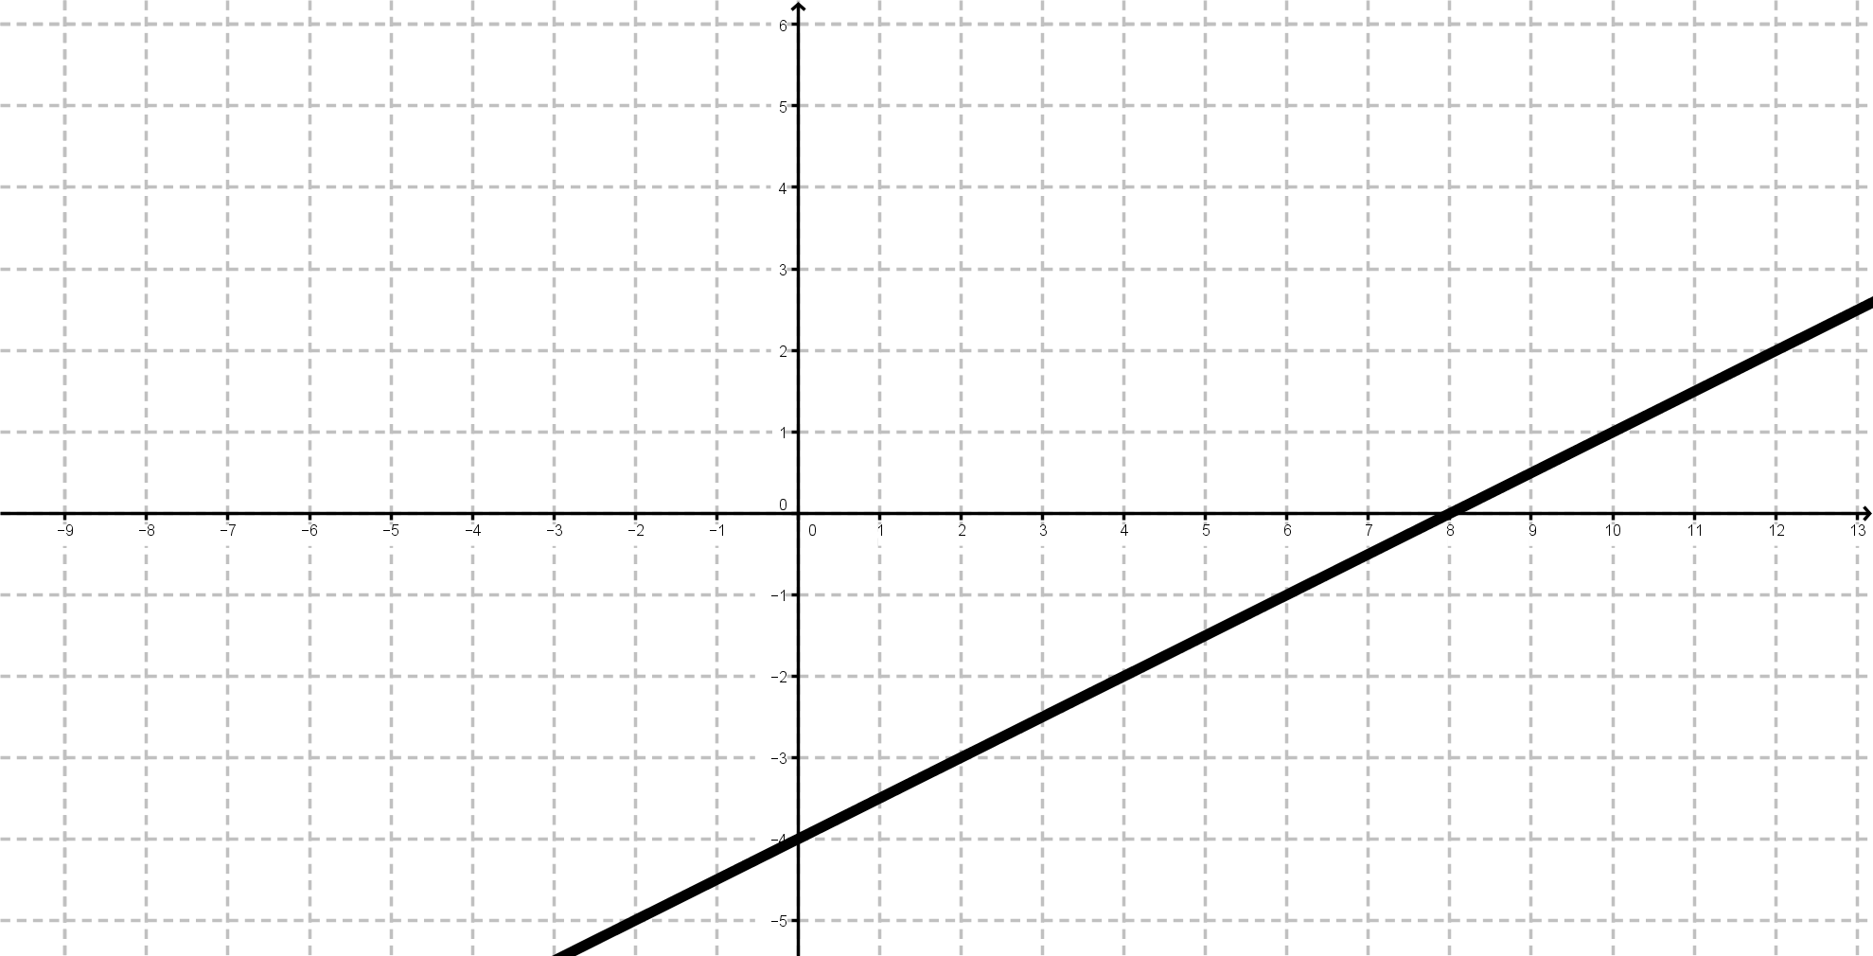

Go to the x value of this graph when y=-1.

4.

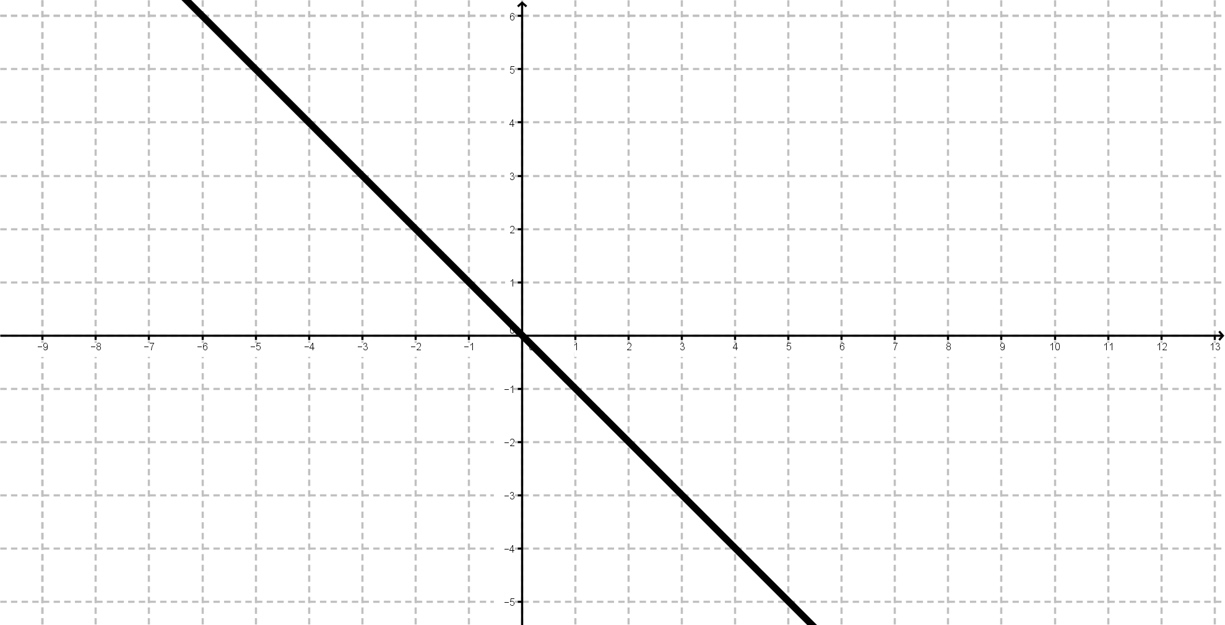

Go to the y value of this graph when x = -13.

5.

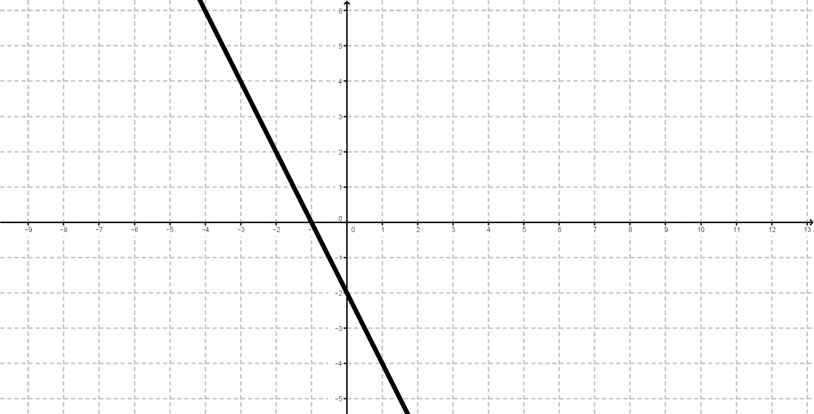

Go to the y value of this graph when x = -8.

6.

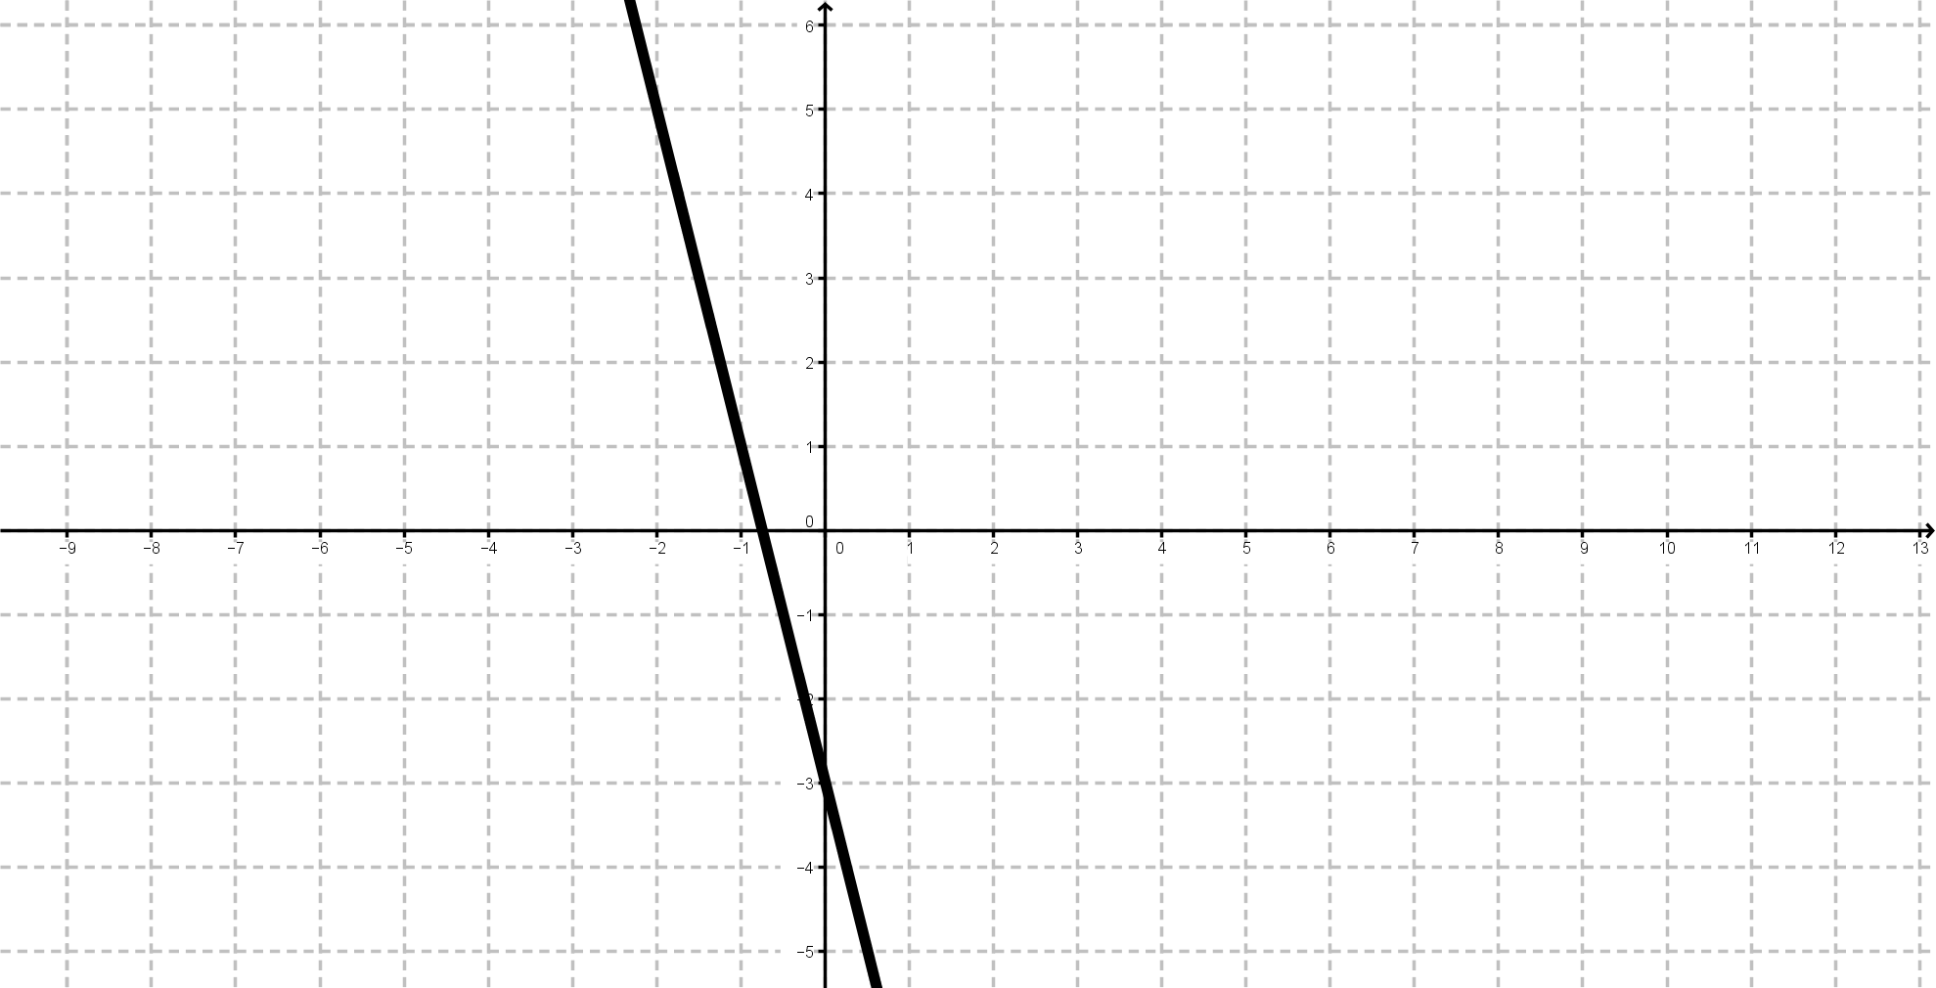

Go to the three times the negative of the gradient of this graph.

7.

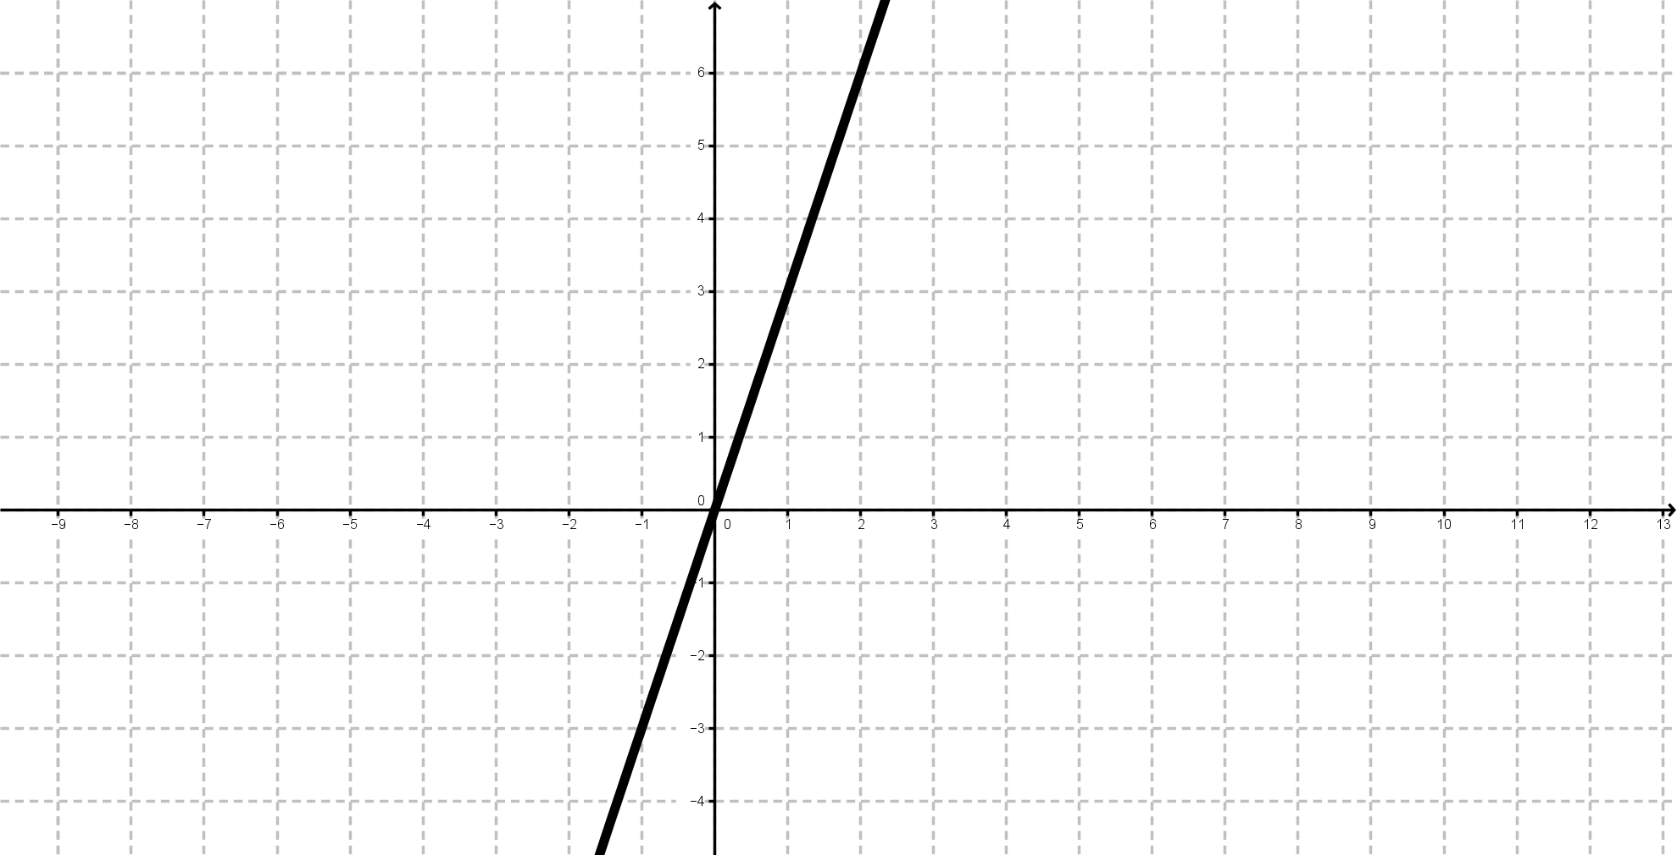

Go to the y value of this graph when x = 5.

8.

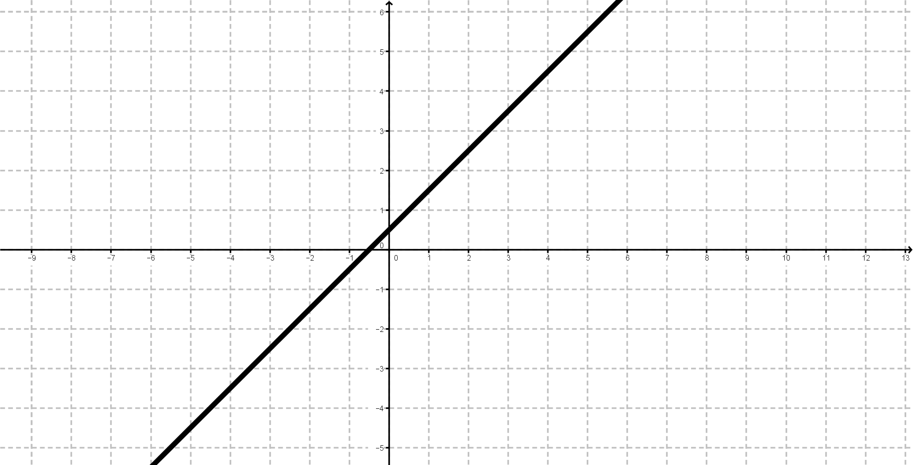

Go to ten plus the gradient of this graph.

9.

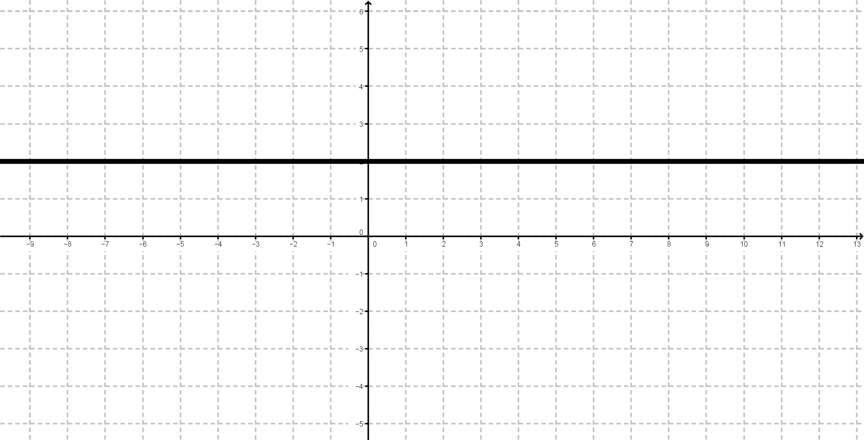

Go to the y-intercept of this graph.

10.

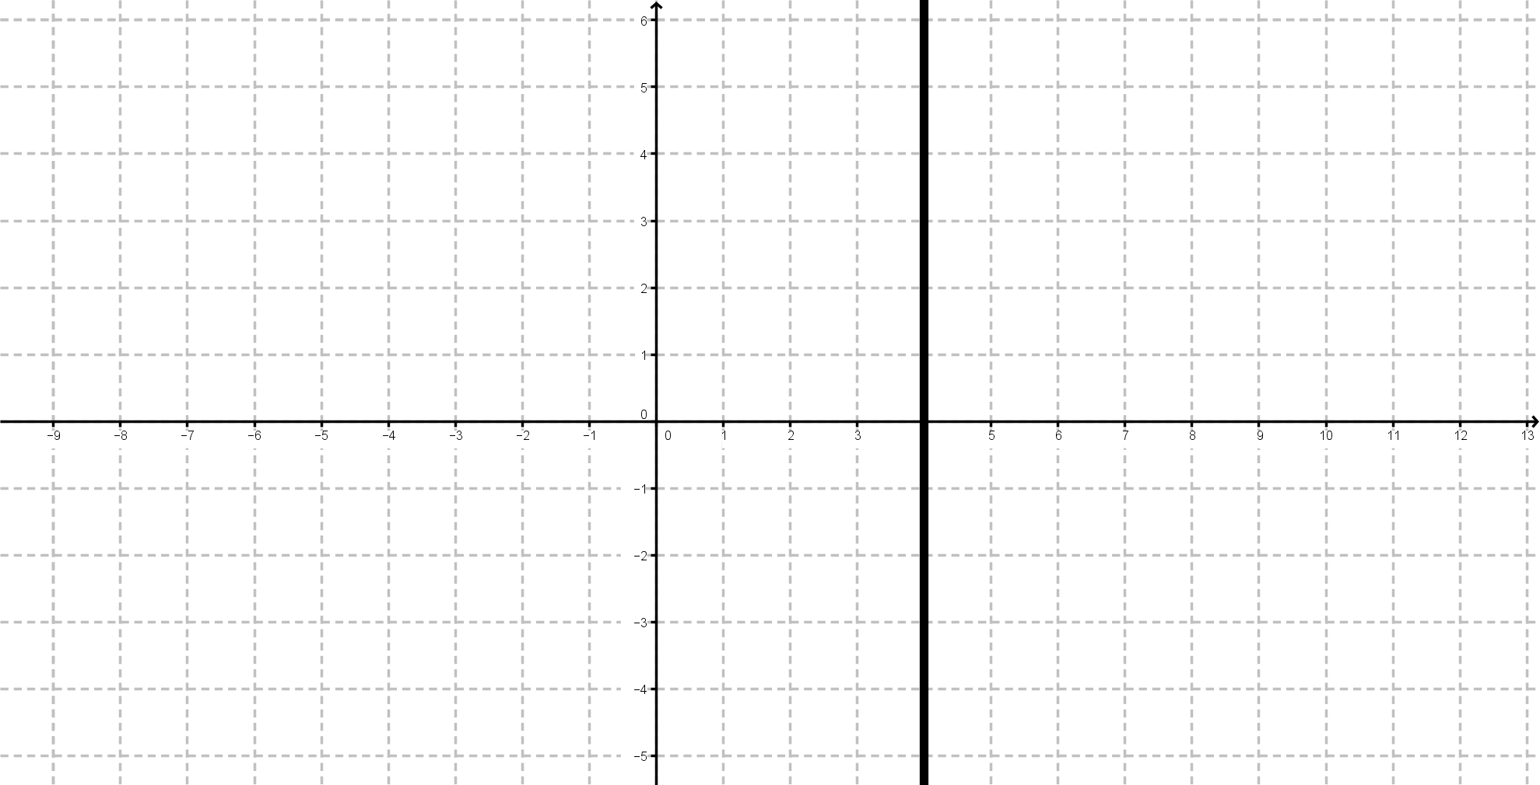

Go to the x-intercept of this graph.

11.

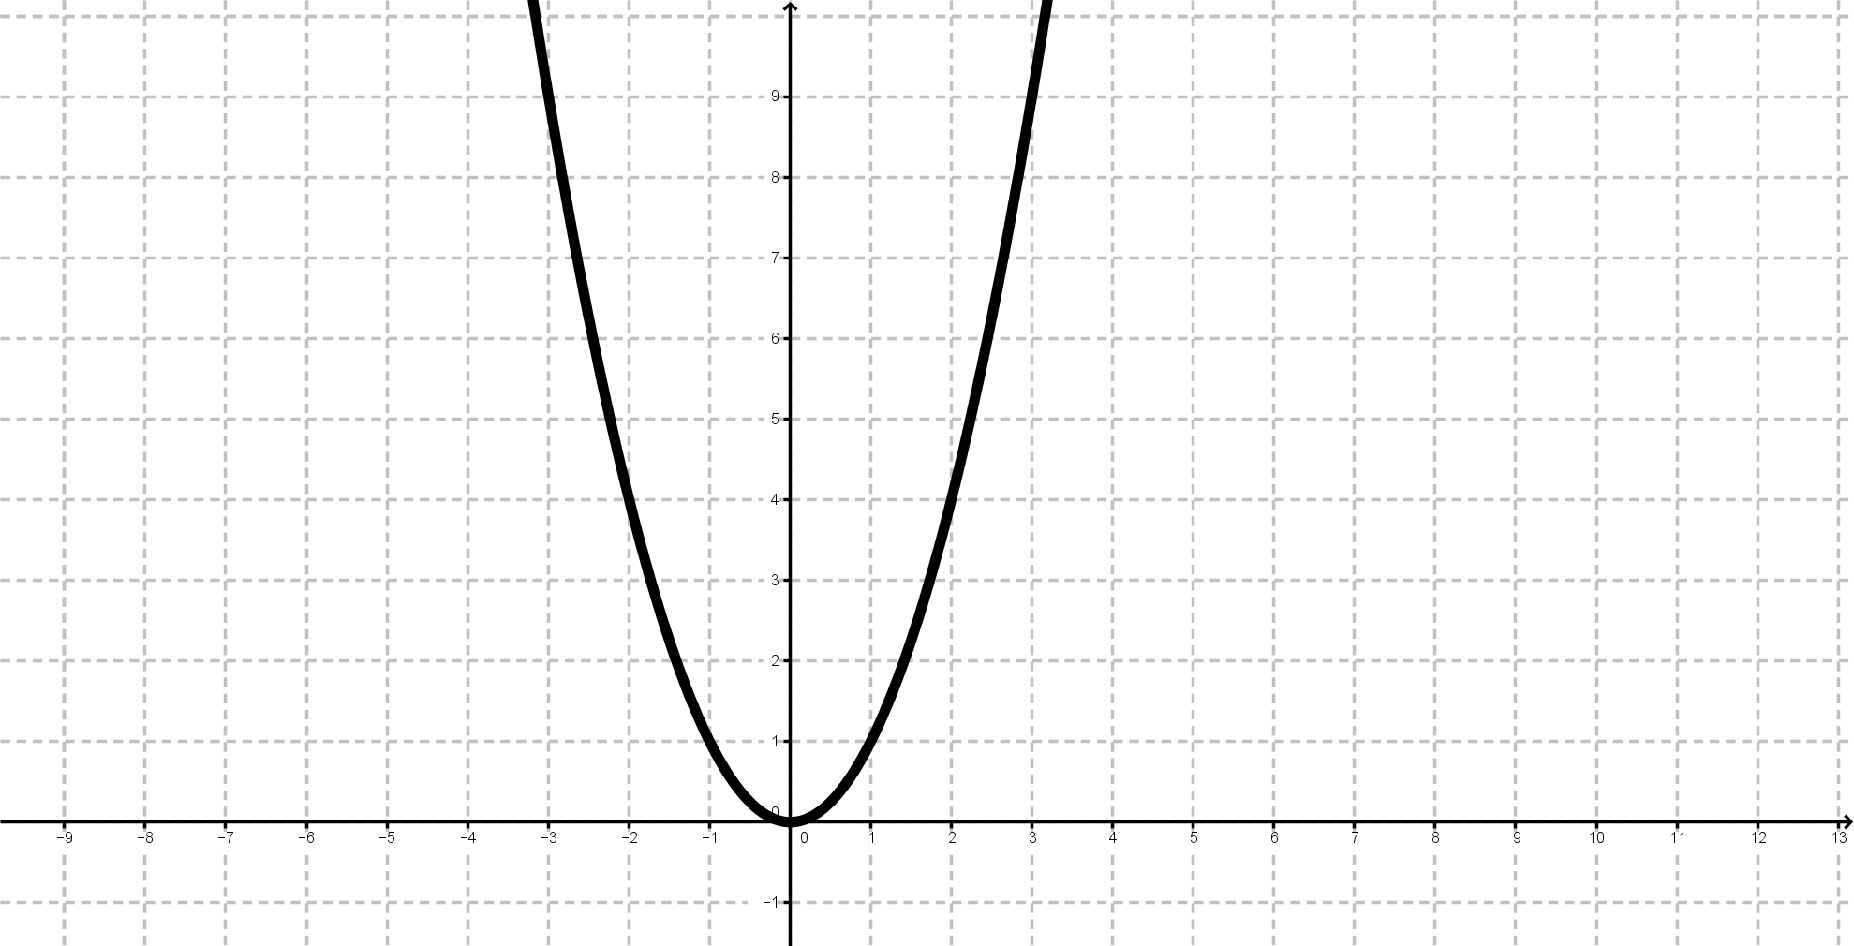

Go to the y value of this graph when x = 2 plus 3.

12.

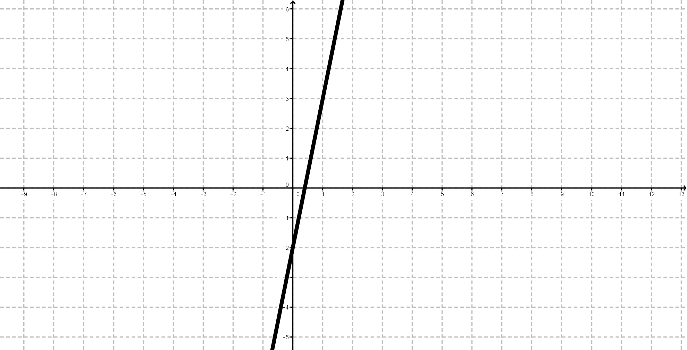

Go to the gradient of this graph.

13.

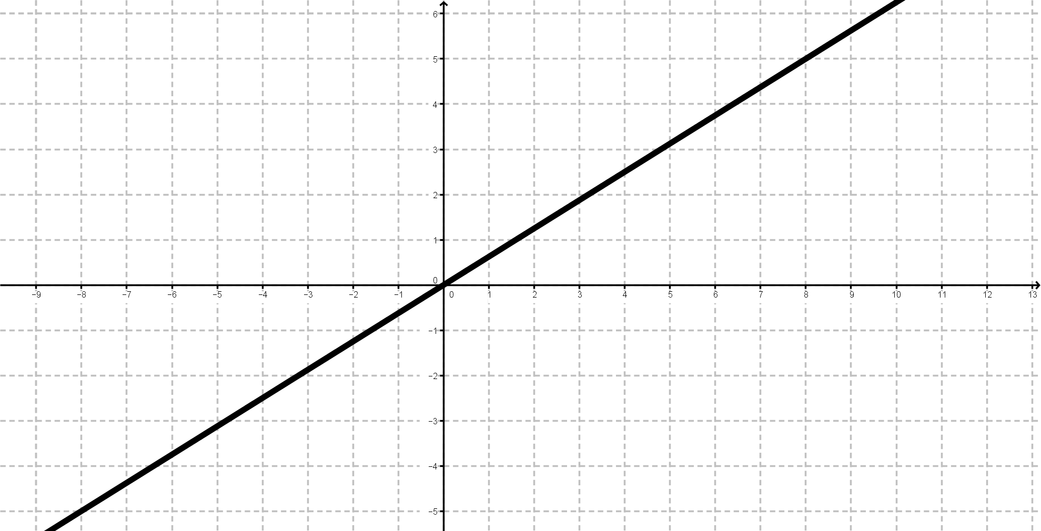

Go to the x value of this graph when y = 5.

14.

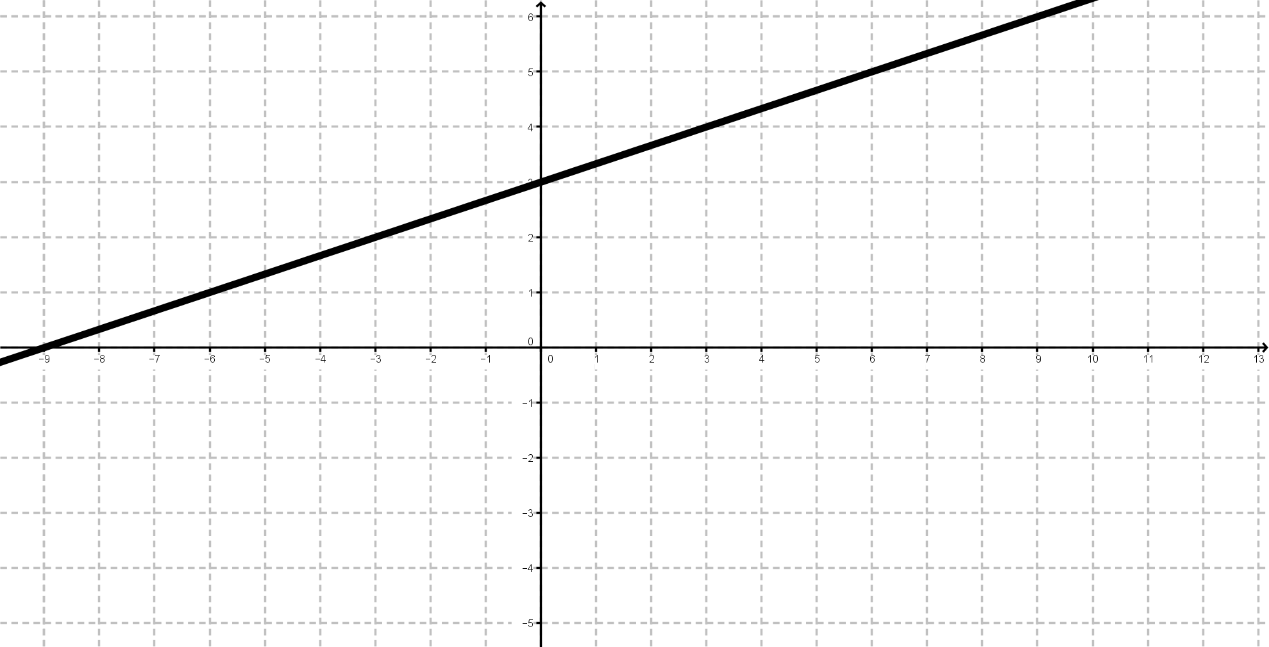

Go to three times they-intercept of this graph.

15.

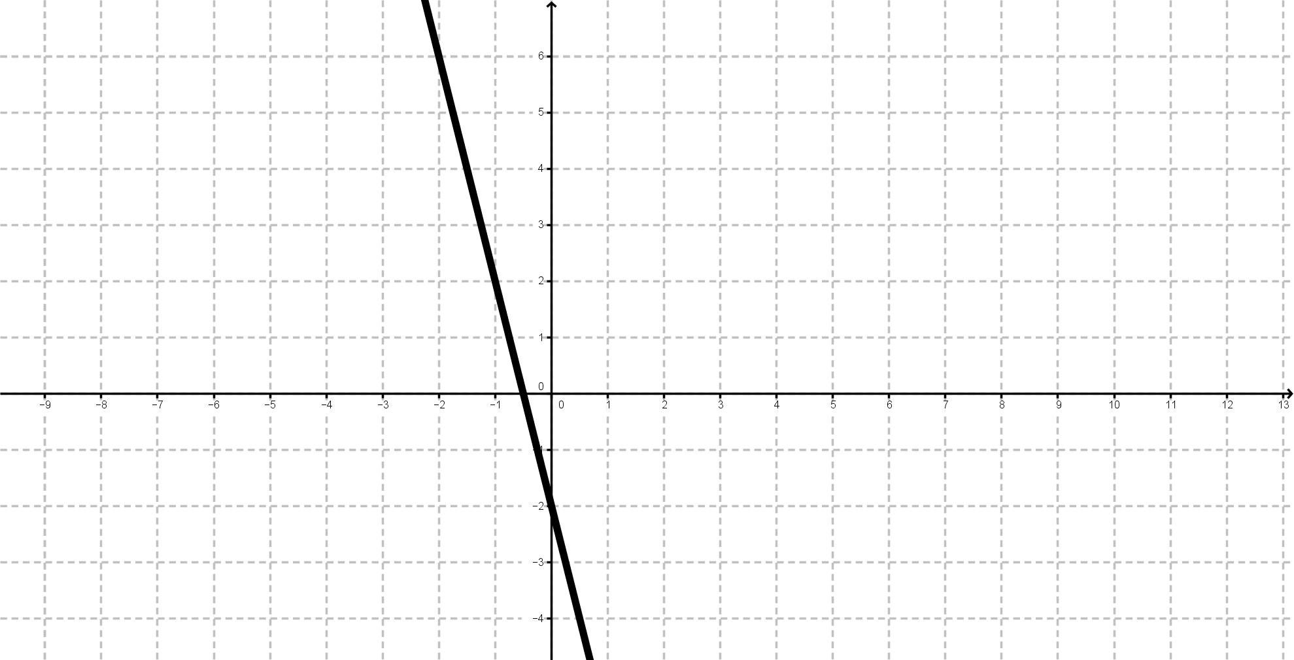

Go to half the y value of this graph when x = -1.

Names ________________________________

Start at any question. Write down the question number and find the equation of the line. Follow the instructions for which question to do next. The first group to find all the equations **in the correct order** is the winner.

|  |  |
| --- | --- |
| **Question** | **Equation of the Line** |
|  |  |
|  |  |
|  |  |
|  |  |
|  |  |
|  |  |
|  |  |
|  |  |
|  |  |
|  |  |
|  |  |
|  |  |
|  |  |
|  |  |
|  |  |

Solution

The order will stay the same, but students may start at any question.

|  |  |
| --- | --- |
| **Question** | **Equation of the Line** |
| 1 | y = 2x + 3 |
| 3 | y = ½x – 4 |
| 6 | y = -4x – 3 |
| 12 | y = 5x – 2 |
| 5 | y = -2x – 2 |
| 14 | y = ⅓x + 3 |
| 9 | y = 2 |
| 2 | y = -½x + 4 |
| 10 | x = 4 |
| 4 | y = -x |
| 13 | y = ⅝x |
| 8 | y = x + ½ |
| 11 | y = x2 |
| 7 | y = 3x |
| 15 | y = -4x – 2 |